Name Of The Student | Garima Modiyani
Internship Project Topic | TCS iON RIO-210: Build a Classification Model for Drug Trials Dataset
Name of the Organization | TCS iON
Name of the Industry Mentor | jignasha royala
Name of the Institute | Amity University

Date | Day | Hours Spent
17-11-2025 | Day-37 | 4 hours 40 minutes
Activities done during the day:

Project Hands-on - Import related modules and dataset file

Link of the google drive google Colab file :-
https://colab.research.google.com/drive/1VQRq0l6oc9Uj4cOOqiuhkfS1JmpKr3fU?usp=sharing

Upload the dataset in google colab.

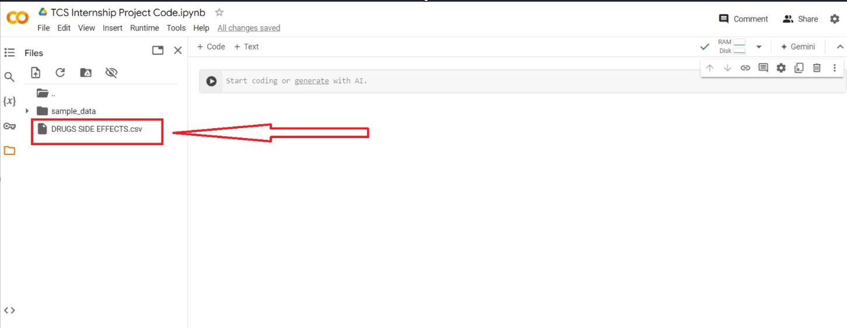

Import required libraries in python:

import pandas as pd

pandas (all lowercase) is a popular Python-based data analysis toolkit which can be imported using import pandas as pd.

It presents a diverse range of utilities, ranging from parsing multiple file formats to converting an entire data table into a NumPy matrix array.
This makes pandas a trusted ally in data science and machine learning.

Import = “Bring this functionality or library to my python script”
Pandas = The library you want to import, in this case, it’s pandas
As = The python nomenclature for creating as alias.
pd = The standard short name for referencing pandas

import numpy as np

NumPy, which stands for Numerical Python, is a scientific computing library built on top of the Python programming language.

The import numpy portion of the code tells Python to bring the NumPy library into your current environment.

import seaborn as sns
import matplotlib.pyplot as plt

Seaborn & Matplotlib the both python libraries is used for data visualization and viewing the graphs

from sklearn.svm import SVC

Support vector machines (SVMs) are a set of supervised learning methods used for classification, regression and outliers detection.

It is C-support vector classification whose implementation is based on svm. The module used by scikit-learn is sklearn.svm.SVC. This class handles the multiclass support according to one-vs-one scheme.

from sklearn.ensemble import RandomForestClassifier

A random forest is a meta estimator that fits a number of decision tree classifiers on various sub-samples of the dataset and use averaging to improve the predictive accuracy and control over-fitting.

from sklearn.model_selection import train_test_split

The train_test_split function of the sklearn.model_selection package in Python splits arrays or matrices into random subsets for train and test data, respectively.

To use the train_test_split function, we’ll import it into our program

from sklearn.metrics import classification_report

A classification report is a performance evaluation metric in machine learning. It is used to show the precision, recall, F1 Score, and support of your trained classification model.

Code:-

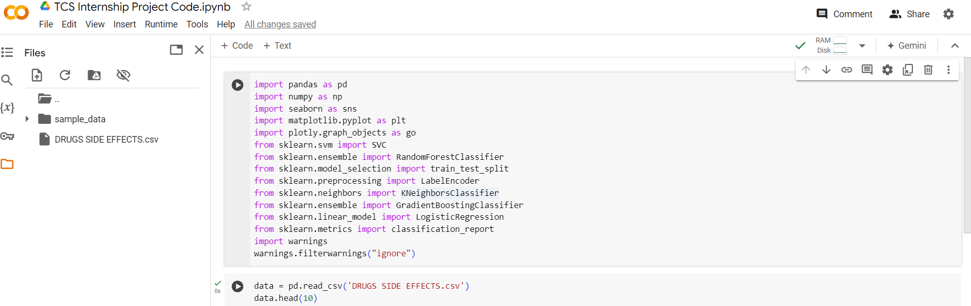

Output:-

